Art/Illustration Strategies
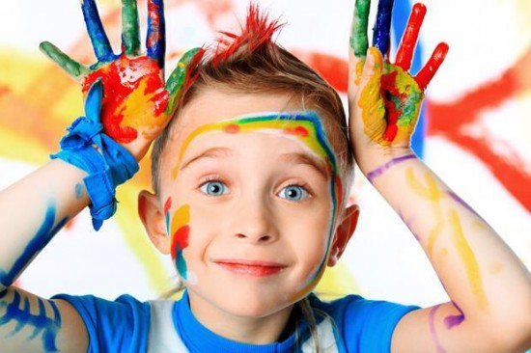
In the visual arts teaching process, it is important to provide a learning environment for the development of the students’ potential abilities to master knowledge and skills, and to keep a positive attitude in the classroom. It is important to encourage student activity, as well as focusing on the use of contemporary teaching strategies and methods, applying different styles of teaching and learning, and it is important for the teacher to respect the students’ development needs and advances. An interactive approach to learning and teaching by using art in education increases the ability for a student to learn all subjects in the educational process. It also promotes creative thinking by using active, student-centered teaching strategies such as active, experiential, independent, investigative, cooperative and problem-solving learning. It can also lead to a better understanding of the curriculum being taught and can increase motivation. A few more good outcomes of art in the classroom is, higher order cognitive skills, greater retention of material and more positive attitudes
Illustration In Reading
When children read they look and pay attention to the pictures and illustrations in the book. Both the words in a book and the pictures help the children gain a deeper understanding of the story.
As children are learning to read and they come across words they do not know they can use pictures as context to help them to gain understanding of what the sentence says.
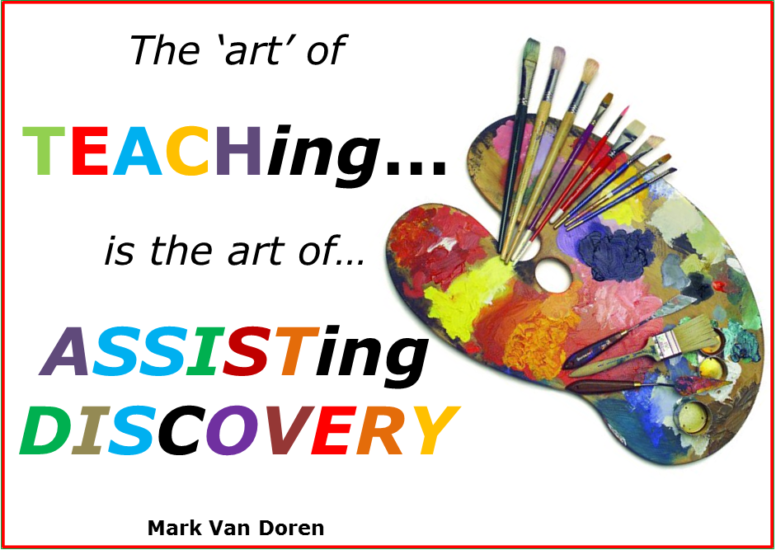

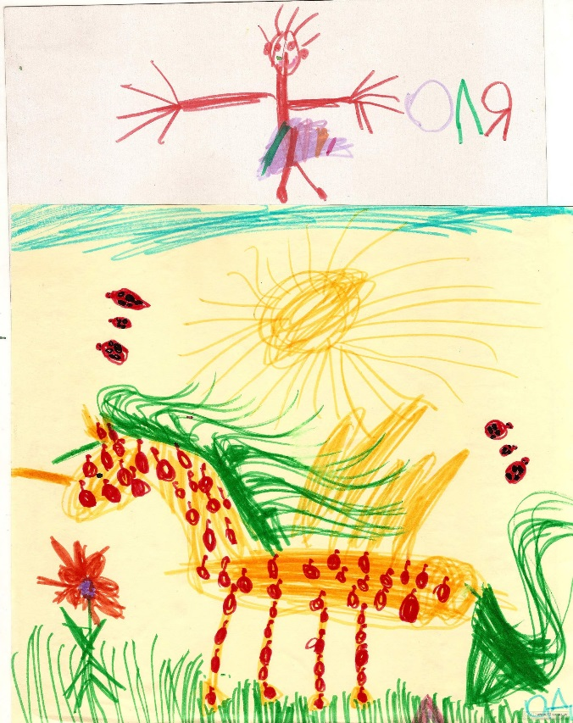
When children are given an assignment that involves creativity they become more excited about the assignment. They have more freedom when working with art and are able to make their learning assignments their own.
For example when you are teaching the alphabet to young children they see, read and say the letters over and over. This can be repetitive and boring for some students. If the teacher as they students make their own alphabet with paints and colors it would have more meaning. The child can make each letter in their own creative way which can lead to deeper understanding.

Student Activity: Drawing a Personal Book

A popular and common activity they teachers have students do is to create their own book.
Step 1: staple pages of paper together
Step 2: have they students draw their cover page
Step 3: have them illustrate the pages before writing the story.
Step 4: go back and write down the story that their pictures are saying.

