Colored Overlays

Colored overlays are thin colored/tinted pieces of film/plastic that are used for students who have a hard time processing or reading printed text. Color overlays are used by placing them directly on the text that is being read, not above the text or over the eye, but directly on the text. Another version of overlays are called lenses, the lenses are typically used for reading text on a computer screen and not printed text.

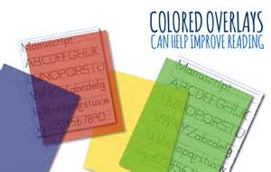

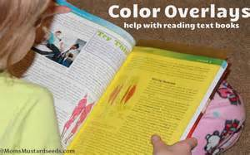

Colored overlays come in many different colors and tints to fit each student’s individual need. Sometimes a student will use a mixture of colors in order to help him or her read the printed text.

Who do colored overlays work for?

There have been many studies done over whether or not colored overlays actually work and if they do who they work for. The main group of students that colored overlays work for are those with Scotopic Sensitivity Syndrome, which is a fancy name for visual stress. SSS is a perceptual processing disorder with which there is a problem with the brain’s ability to process visual information. Colored overlays have also been found to help students with the reading disability known as dyslexia and even some cases of high functioning Autism. They have even been found to help some students with ADHD (in some cases the ADHD was paired with a reading disability). Colored overlays have even appeared to help students who do not have a reading disability or anything of the sort by improving reading speed and understanding. Although colored overlays have had many positive results for a lot of students it has been shown that they do not work with all at-risk readers.

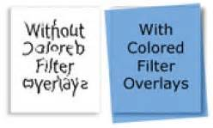

How can teachers use Colored Overlays in the Classroom?

In the classroom implementing the use of Colored overlays is not hard if the resources are available. The colored overlays need to be provided for the students who seem to be struggling with reading printed text, not just reading long paragraphs and stories, anything printed can hinder a student’s ability to read and process the information. After the colored overlays are provided to the students they then need to be taught the proper way to use the overlays. The students need to be instructed that the overlays are to be placed directly on the printed text that is being read, not up in the air over the text or over the eyes. While teachers can provided colored overlays to all students, if resources are limited those who benefit most should receive the aide that they need. If a child seems to be struggling in this area but the colored overlays are not proving to be affective it is important as a teacher to look into what might be the actual issue so that the student is ensured a valuable education.

How/why do Color Overlays work?

Different colors give off different wave lengths and, often times, those wavelength make it difficult for students to process the words of a page of printed text. Sometimes even the lighting in a room and make is difficult. What color overlays do is selectively reduce inputs of troublesome wavelengths of light and alter the light from the printed page before it enters the eyes. Basically the colored overlays eliminate the elements that make it difficult for students to process and read the words on a page of printed text. By doing so the colored overlays reduce the symptoms of visual stress such as headaches and watery eyes.

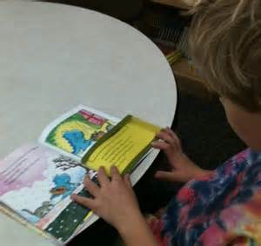

* Rickelman, R.J. & Henk, W.A. (1990). Colored Overlays and tented lens filters. Reading Teacher, 44(2), 166-168.
* Iovino, I. R. (1998). Colored Overlays for visual perceptual deficits in children with reading disability and attention deficit/hyperactivity disorder: Are they differentially effective?. Journal Of Clinical & Experimental Neuropsychology, 20(6), 791.
* Wilkins, A. (2002). Coloured overlays and their effects on reading speed: a review. Ophthalmic & Physiological Optics, 22(5), 448-454.
* Ludlow, A.P. (2006). The effect of coloured overlays on reading ability in children with Autism. Journal of Autism & Developmental Disorders, 36(4), 507-516.