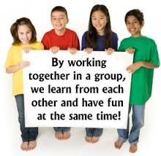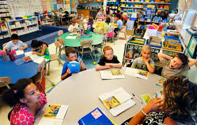

There are many cooperative strategies that teachers implement in their classroom one of these strategies is a cooperative learning group. Studies have shown that placing children in learning group allows them to perform better academically. “Slavin (1995) defined cooperative learning as ‘a variety of teaching methods in which students work in small groups to help one another learn academic content’. Research has proven that when students with disabilities are grouped with “typically developed” students they perform better academically. On many occasions students with disabilities are pulled away from the class and placed into a separate class. Researchers are proving that this is not the best solution.

Learning groups in the classroom

The process of categorizing students into groups and assigning jobs to each individual students, which allows them to work together.

**Who will it help???**

Everyone!!!! This strategy will help typically developed children as well as children with learning disabilities, emotional behavior disabilities, ADHD, etc.

Creative Cooperative Learning Groups & Assigning Jobs / Roles

Categories for grouping

*Grade level

*Personality

*Interest

*Learning type

*Abilities

*Communication skills

*Academic Skills

*Behavioral aspects

*Social Skills

*Emotional Level

*Prelock, P. (2000). Clinical Forum: prologue. Multiple perspectives for determining the roles of speech-language pathologist in inclusionary classrooms.

*Andre, A.P. (2013). Cooperative group, risk-taking and inclusion of pupils with learning disabilities in physical education.

*Cowden, P.A. (2012). Cognitive Strategies for Students with Mild Learning Disabilities.

*\**Brinton, B., & Fujiki, M. (2000). Children With Language Impairment in Cooperative Work Groups: A Pilot Study

**Implementing the strategy**

Step One: Explain activity

Step Two: Separate into groups

Step Three: Assign and explain roles

**Steps Prior to Implementing Strategy**

Step One: Teacher completes TBRS (teacher behavior rating scale)

Step Two: Create the activity

Step Three: Determine the objective

Step Four: Decide how many students will go in each group

Step Five: Determine how to split the class

Helpful Tips: Always place the disabled students in the center of the group. Monitor the groups without “controlling” the activity.

Benefits

*Leader

*Checker

*Reporter

*Recorder

*Material Manager

*Starter

*Reader

*Researcher

**Jobs / Roles**

*Opens the children’s minds to diversity

*Allow the students to their individual differences

*Increases interactions among peers

*Gives students a voice

*Inclusion in the classroom

*Ensures equal opportunity