DESCRTIPTION OF THE STRATEGY
Cornell note-taking is a method of note-taking arranged in a way that allows you to take notes in a quick and organized way. You can use them in lecture or while reading a chapter from a textbook by writing keywords, main ideas, and summarizing what you have learned.

WHAT CHARACTERISITICS IT WILL HELP THE STUDENT OVERCOME?
Students with disabilities often have difficulties taking notes during lectures and studying. Students with disabilities have problems with recording notes during lectures such as; writing fast enough to keep up with the pace of the lecture, paying attention during the lecture, making sense out of their notes after class (legibility), and deciding what was important to record during the lecture. Many of these note-taking difficulties often result in notes with either partial or incomplete lecture points.
Implementation of Cornell note-taking addresses all these issues by creating a note-taking style that is quick, clear, and structured

Could this strategy be used for everyone in the inclusion classroom?
Lecture in the classroom is continuous, class after class, and students are constantly taking in information and updating their preexisting knowledge. Younger and less skilled students, record notes to help them look back at what was presented in lectures and build on their knowledge. The more efficient that a student can build on this information leads to subsequent gains on recalling and comprehension. This allows all students using the Cornell note-taking style to benefit from its use.

PROCEDURES FOR IMPLEMENTATION
Introduction
The first step is to introduce the new format of note taking. Seeing a visual as you explain the process will help make your descriptions and explanations much more clear.
Modeling
Having a template ready and printed for the class, as well as yourself, allows you to model how to correctly take notes using this method.
As you read the information you can discuss with the class where the main ideas, keywords, and questions are and where they should go. This will give insight to the students about the decisions that help determine how to condense the main body into a few sentences.
Guided instruction
As you read the information you can have a think-aloud about how students selected keywords and paraphrased main ideas from the first paragraph. Then have them look ahead and a think-aloud about keywords and paraphrased main ideas for the second paragraph.
Collaboration
To encourage independence allow the students to take notes on their own.
Strategically place students in groups of two pairing those who were experiencing more success with others who needed additional support.
Have each student in the group take turns writing notes and summarizing the information to their partner
Have groups collaborate with another team to share summaries and determine if important information needed to be added or irrelevant details needed to be removed.
Independent Practice
Once the students need less support have each student write their own notes. Provide student who still need support a template with keywords, some may need a blank template while other prefer creating their own.

How to use Cornell notes
STURUCTURE
A paper is divided into 3 parts
1. A left side column that is designated for given cues and keywords
2. The right side column which is larger than the left is designated for general notes that go with the cues and keywords
3. Lastly at the bottom of the page is a section for summarization of what was learned
DURING LECTURE
In the left column you could write important vocabulary words, dates, people or ideas.
While in the right you would write notes that go along with those topics.
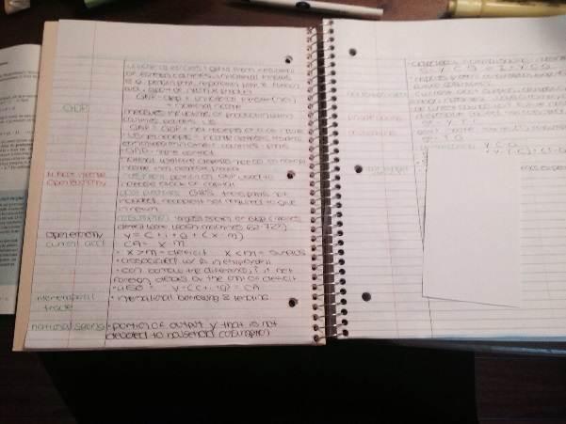
AFTER LECTURE
As soon as possible while the information is clear in your head review your notes and revise what is necessary. This could mean adding in notes, removing notes or simply making your own notes more legible. Once you’ve review you could write a summary about your notes and the lecture.
Boyle, J. R. (2010). Note-taking skills of middle school students with and without learning disabilities. Journal Of Learning Disabilities, 43(6), 530-540. doi:10.1177/0022219410371679

Cornell Notes / Guided Notes

by [Article Author]

Boyle, J. R. (2013). Strategic note-taking for inclusive middle school science classrooms. Remedial And Special Education, 34(2), 78-90. doi:10.1177/0741932511410862

Forchelli, G. A. (2014). Differences in the note-taking skills of students with high achievement, average achievement, and learning disabilities. Learning & Individual Differences, 359-14.

Donohoo, J. (2010). Learning How to Learn: Cornell Notes as an Example. Journal Of Adolescent & Adult Literacy, 54(3), 224-227.

References

