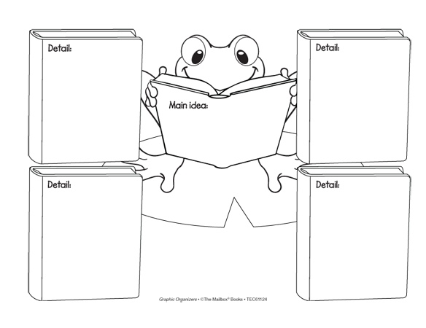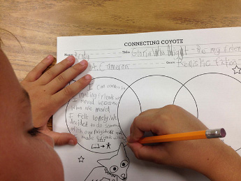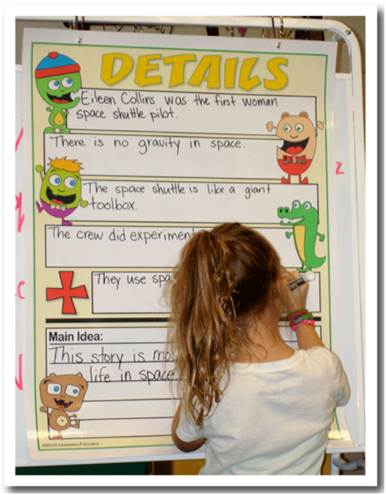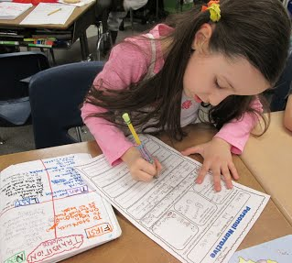 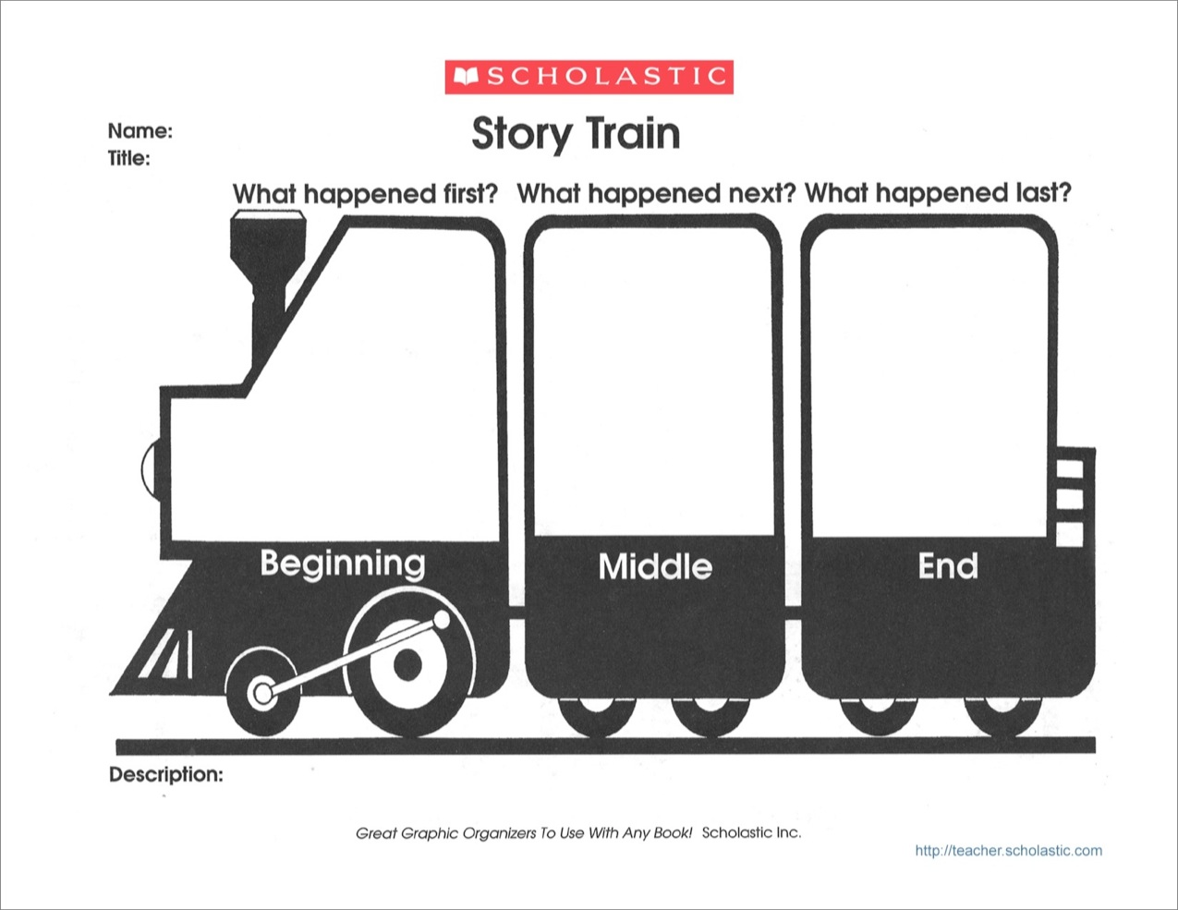

Often students’ with Learning Disabilities (LD) are visual learners and thinks, which is why using graphic organizers in reading is a great strategy for them to use. By using graphic organizers in reading for students with LD it can help them understand and remember the information being read because they are able to associate their thoughts with pictures, charts, and diagrams. However, all students can benefit from using graphic organizers in reading.

# Graphic Organizers in Reading

Graphic organizers in reading is a visual thinking tool that helps create a relationship between ideas, facts, or concepts within a story by using a map or diagram.

Reading graphic organizers help students visualize how ideas fit together. This strategy also helps students compare and contrast, show cause and effect, brainstorm, construct meaning with what they read, organize information, and help increase their reading comprehension. By using graphic organizers in reading teachers are able to identify strengths and weakness of their students’ thought processes on what the students read. Graphic organizers can be used independently, as a class, or in groups.

Desiree Nix - 23

The teacher can provide many different graphic organizers in reading such as: Venn diagrams, concept maps, webs, stack plots, and K-W-L charts. Teachers can access many different types of reading graphic organizers on the Internet.

##### Procedures for

##### Implementations:

References:

Baxendell, B.W. (2003). Consistent, Coherent, Creative The 3 C’s of Graphic Organizers. *Teaching*

*Exceptional Children,* 35(3), 46.

Hall, C.c., Kent, S.C., McCulley, L., Davis, A., & Wanzek, J. (2013). A New Look at Mnemonics and

Graphic Organizers in the Secondary Social Studies Classroom. *Teaching Exceptional Children,*

46(1), 47-55.

Singleton, S.M., & Filce, H.G. (2015). Graphic Organizers for Secondary Students With Learning

Disabilities. *Teaching Exeptional Children,* 48(2), 110-117.

1. When choosing a reading graphic organizer the teacher needs to consider how the reading is structured. Based off the structure of the reading the teacher then can select a graphic organizer that matches the way the reading is structured.
2. Give the students a short explanation as to how the specific graphic organizer can help their comprehension of the text.
3. Model the proper way to fill out the graphic organizer in reading. While modeling how to write information give the students opportunities to participate with helping fill out the organizer.
4. After the teacher has modeled the proper way to use the graphic organizer, and the students have a better understanding of what it is and how to use it, transfer the responsibility of completion to the students.
5. Once all the students have completed their graphic organizer in reading, have the students explain their ideas represented in their finished product.

Continued …