

**Who does the strategy not help in mathematics?**

* ADD
* ADHD
* Students who have short attention span.
* Students who struggle with comprehension by themselves.

**There is a lack of communication and cooperation for the student……..**



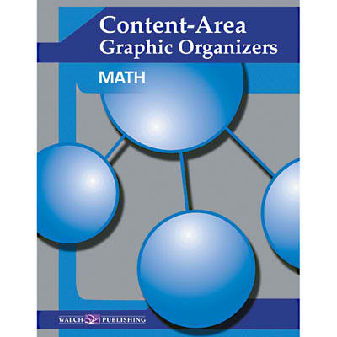

What is the **Rhombus Strategy**?

* Using a Graphic Organizer to help students better assemble the math data that appears in word problems.

**Five Step Process:**

1. The student states the math problem in their own words.
2. Then the student decides what information is relevant to the solution.
3. Next the student proceeds to order the appropriate steps to solve the math problem.
4. The student then executes the necessary steps for the solution.
5. Lastly the student then decides if this is a reasonable answer by referring back to their previous work.

**Conclusion:**

* Allowed students to slow down and think before acting.
* Allowed for Visual Organization.
* Allowed an understanding of the problem through a written process.

**Overall they concluded that the strategy was a success…….**



2. Next in their groups students should collaborate with one another to see if they used the strategy correctly. (Tell)

3. Lastly allow students to share their findings with the class and allow the teacher to check their understanding. (Share)

**Note: The teacher should help engage students in their group during the Tell strategy.**

**Conclusion:**

* **Cooperation**
* **Communication**

**Using the Rhombus Strategy:**

**Teacher-**

1. **Lead the class through the Rhombus Strategy.**

* **Call on students as you work through the problem (Reading, Info needed)**

1. **Break students into groups to use the Rhombus Strategy.**

**Students-**

**1. Use the Rhombus strategy on your own to see your knowledge of the problem. (Think).**

Main Technique:

**Rhombus Strategy:**

1. Find the Question
2. Determine the important Data
3. Plan your steps
4. Find your answer in the 3 step process
5. See if answer is reasonable

Side Techniques:

**Real World Scenarios:** provide word problems that students can relate to and show how math does matter in their lives.

**Think Tell Share:**

1. Allow the student to think about the problem in their own minds.
2. Allow the student to share their thoughts with a group to help each other out.
3. Allow students to share as a class and for the teacher’s response.

**Works Cited:**

Braselton, S., & Decker, B. C. (1994). Using graphic organizers to improve the reading of mathematics. Reading Teacher, 48276-281.

Furner, J. M., Yahya, N., & Duffy, M. L. (2005). Teach Mathematics: Strategies to Reach All Students. Intervention In School & Clinic,41(1), 16.

Thornton, C. A. (1991). Think, tell, share—success for students. Arithmetic Teacher, 3822-23.

Pictures from Google images.



