Math Games
A math game is a game whose rules, strategies and outcomes are determined by a mathematical concept. They are typically simple. Younger students (k-2) enjoy games that are based on chance. Older students (3+) enjoy games based on strategy.
Who it works for:
This strategy works for all students! It’s ideal for an inclusion classroom. Math games work for students with ADHD, autism, emotion disturbances, learning disabilities, and hearing impairments.

How to do it:
- It is easy to implement a math game as long as you use the three P’s: Plan, Play, be Patient!
- 1st thing: Play the game yourself, find the math concepts, modify for age level, and think of questions for during play.
- Plan: How will you introduce the game, how long it will take, how will the students be grouped, and who will be in the groups?
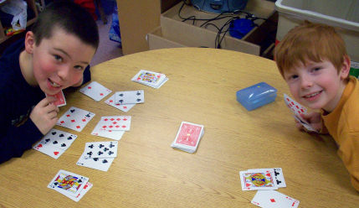
- Play: monitor conversations, ask probing questions, and record strategies for a class discussion at the end of the game. Pull a few different strategies and present them from the lowest sophistication to the highest. Ask the students how they are similar and different. Invite the students to use a different strategy the next time they play.
- Be Patient: give time for the students to play multiple times. This way they have a chance to independently play with strategies they come up with on their own.
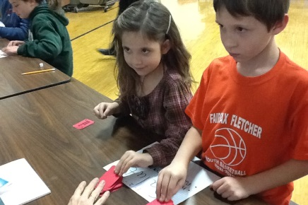
Why it works:
- It is fun! Students will stay engaged.
- Easy way to explore new concepts.
- Develops mathematical reasoning.
- Great for comparing strategies. Allows students to see how other students are working things out.
- Fosters discussions about math.
- Perfect for a Cognitively Guided Instruction. It allows students to work out concepts in a way that makes sense to them.
- A great way to scaffold. By having students on different levels work together, it can boost the lower student to that next level.

References:
Olson, J.C. (2007). Developing Students' Mathematical Reasoning through Games. Teaching Children Mathematics, 13(9), 464-471.
Christy, D.M. (2006). The Whimsical Path to Math: Implementing the Navigation Series. Teaching Children Mathematics, 12(6), pp. 323-331.
Kirkby, B. (1986) Math Games Workshop: Part 1. Mathematics in School, 15(4), 19-21.
Some Math Game Links:
themeasuredmom.com/math-games-for-grade-3-and-up/
topnotchteaching.com/lesson-ideas/cool-math-games/

