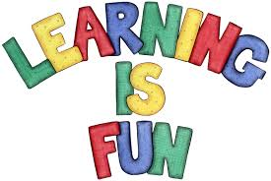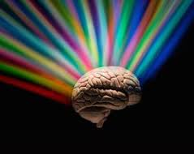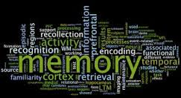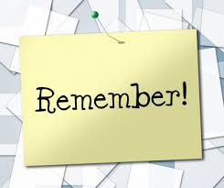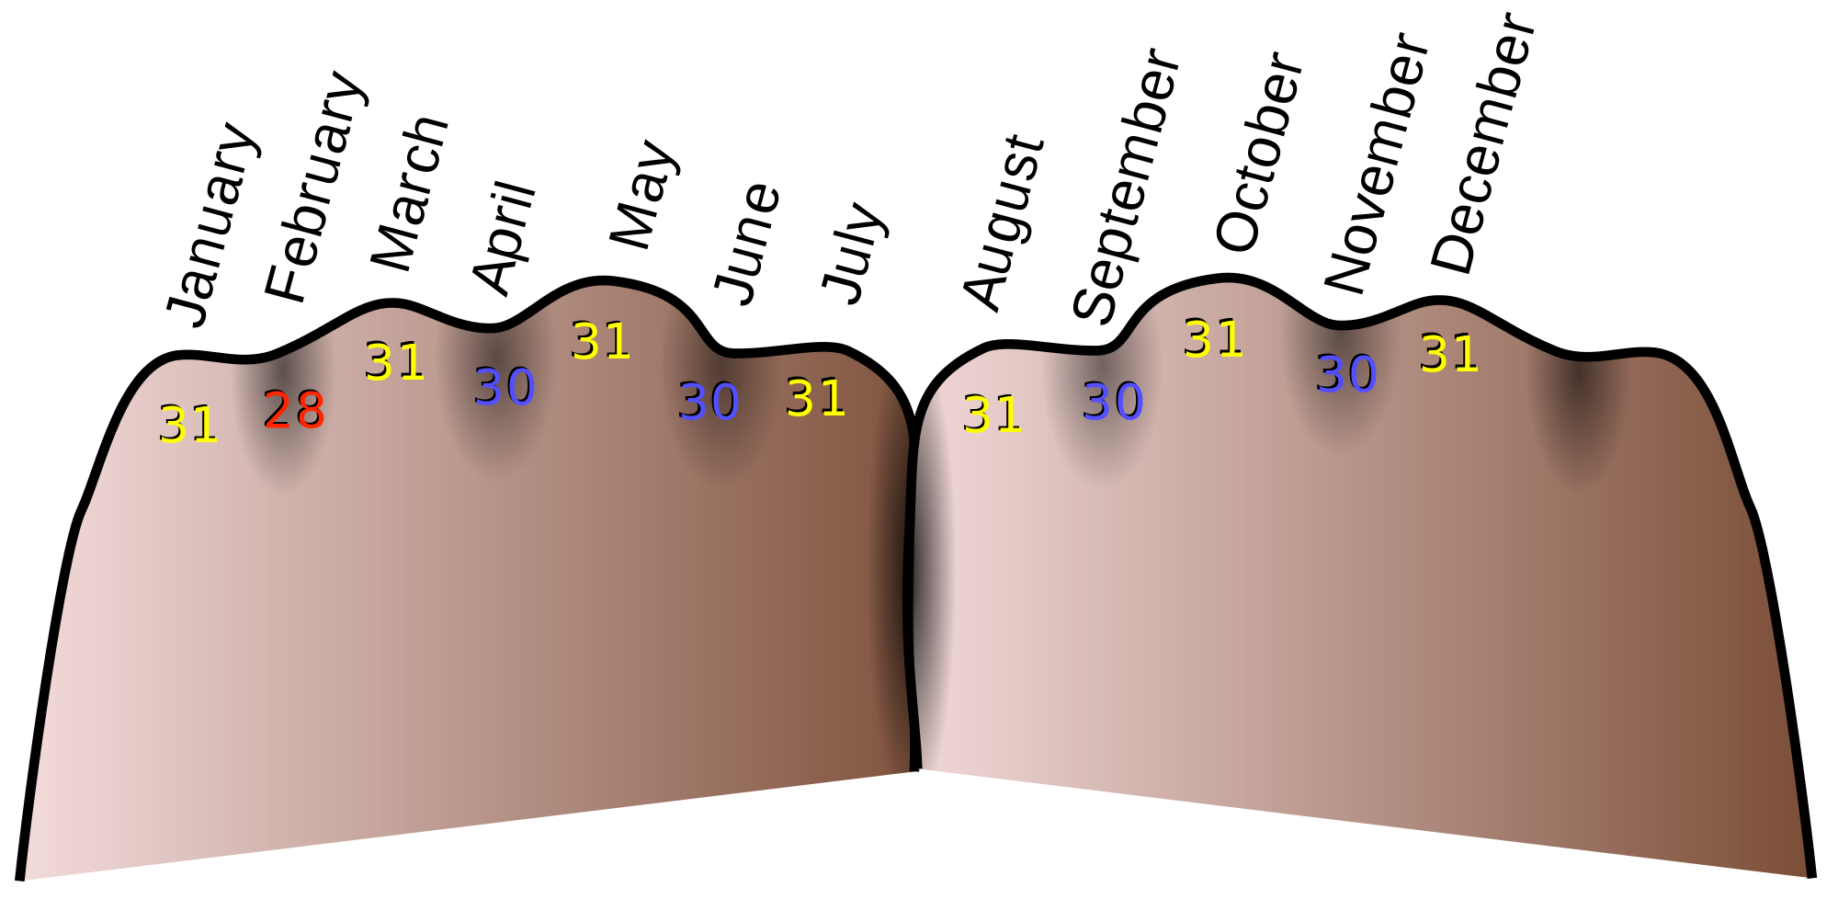

EVERYONE!!!!

Mnemonic devices can be used to help any type of student. These devices are used to help with students with poor memory. It is specifically directed to children with learning disabilities but they are not the only ones who can benefit from this strategy.

+

Who can this strategy help??

Step Three

Either create your own device or research popular devices that are used. You could even have your students come up with their own.

Decide what kind of mnemonic device should be used. Verbal or Visual?

Figure out what information requires the use of a mnemonic device. What are the students having the most difficulties remembering?

Step Two

Step One

Mnemonic Strategies

STEPS:

According to an article, “Comprehensive review of mnemonic devices and their applications: State of the art”, a mnemonic is defined as a “systematic procedure for intensification of memory.”

A mnemonic device creates a connection between new information taught and information already received.

This strategy gives children an easier way to take in information and to remember that information for further knowledge.

## What is it???

+

Hall, C. c., Kent, S. C., McCulley, L., Davis, A., & Wanzek, J. (2013). “A New Look at Mnemonics and Graphic Organizers in the Secondary Social Studies Classroom”. *Teaching Exceptional Children.*

Jurowski, L., Jurowska, A., & Krzeczkowska, M. (2015). “Comprehensive review of mnemonic devices and their applications: State of the art”. *International E-Journal Of Science, Medicine & Education.*

Mastropieri, M. A., & Scruggs, T. E. (1994). “Applications of mnemonic strategies with students with mild mental disabilities. *Remedial & Special Education*

Wolgemuth, J. R., Cobb, R. B., Alwell, M. (2008). “The Effects of Mnemonic Interventions on Academic Outcomes for Youth with Disabilities: A Systematic Review”. *Learning Disabilities Research & Practice.*

**

EXAMPLES:

* Days of the month using fist as shown in the figure on the left. Months with thirty days will be on the creases of the knuckles and the months with thirty-one will be at the top knuckles.
* “Christopher Columbus sailed the ocean blue in fourteen hundred and ninety two.
* North, South, East, and West; **N**ever **E**at **S**our **W**atermelon
* PEMDAS: Parenthesis, Exponents, Multiplication, Division, Addition, Subtractions; **P**lease **E**xcuse **M**y **D**ear **A**unt **S**ally

Visual

**A visual mnemonic is when a picture is associated with a word, phrase, or sentence.**

Verbal

**A verbal mnemonic is when acronyms, rhymes, or rhythms are used as memorization techniques.**

### Verbal VS. Visual