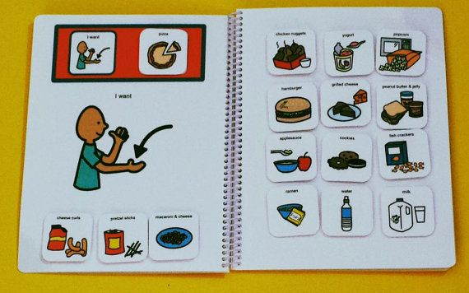
Picture Exchange Cards (PECS) Marilyn Hamby #14
Charhop, M. H., Malmberg, D. B., & Berquist, K. L. (2008, June 19). An Application of the Picture Exchange Communication System (PECS) with Children with Autism and a Visually Impaired Therapist. http://eds.b.ebscohost.com/eds/pdfviewer/pdfviewer?vid=8&sid=d5dd9dc2-00ab-4590-bba8-f2123b4497db@sessionmgr102&hid=117
Mclay, L., Meer, L. V., Schäfer, M. C., Couper, L., Mckenzie, E., O’Reilly, M. F., . . . Sutherland, D. (2014). Comparing Acquisition, Generalization, Maintenance, and Preference Across Three AAC Options in Four Children with Autism Spectrum Disorder. Journal of Developmental and Physical Disabilities J Dev Phys Disabil, 27(3), 323-339. http://resolver.ebscohost.com/openurl?sid=EBSCO:edswss&genre=article&issn=1056263X&ISBN=&volume=27&issue=3&date=20150601&spage=323&pages=323-339&title=JOURNAL OF DEVELOPMENTAL AND PHYSICAL DISABILITIES&atitle=Comparing Acquisition, Generalization, Maintenance, and Preference Across Three AAC Options in Four Children with Autism Spectrum Disorder&aulast=McLay, L&id=DOI:&site=ftf-live
Picture Exchange Communication System™. (n.d.). Retrieved March 30, 2016, from https://www.carautismroadmap.org/picture-exchange-communication-system/
http://www.pecsusa.com/pecs.php

PECS was created to allow children with autism to communicate functionally and purposefully, as nearly 50% of children with autism fail to acquire functional speech.

Who does it work for?
- Children with:
  - Autism
  - Students with a learning disability
  - Students with emotional and behavior disorders
  - Dyslexic children
  - English as a Second Language learners
  - Can also be an activity for all students in an inclusion class
- Will not work with students that are visually impaired unless Braille is added.
- The Picture Exchange Communication System commonly used with nonverbal children to assist their communication with others

- The Picture Exchange Communication System (PECS) is a visually-based alternative and augmentative communication system that is considered appropriate for many special populations.
- It is a behaviorally-based intervention designed to teach functional communication skills to children with limited to no existing communication skills, including children with Autism Spectrum Disorder (ASD).

How to use PECS
Phases of how it works:
- PHASE I
How to Communicate
Students learn to exchange single pictures for items or activities they really want.
- PHASE 2
Distance and Persistence
Still using single pictures, students learn to generalize this new skill by using it in different places, with different people and across distances. They are also taught to be more persistent communicators.
- PHASE 3
Picture Discrimination
Students learn to select from two or more pictures to ask for their favorite things. These are placed in a communication book—a ring binder with Velcro® strips where pictures are stored and easily removed for communication.
- PHASE 4
Sentence Structure
Students learn to construct simple sentences on a detachable sentence strip using an “I want” picture followed by a picture of the item being requested.
- PHASE 5
Answering Questions
Students learn to use PECS to answer the question, “What do you want?”
- PHASE 6
Commenting
Now students are taught to comment in response to questions such as, “What do you see?”, “What do you hear?” and “What is it?” They learn to make up sentences starting with “I see”, “I hear”, “I feel”, “It is a”, etc.

Teachers can use the cards to help the students:
- A daily schedule.
- Show rewards.
- Ask questions.
- Give examples.

Student can hand teacher a picture card when they are in need of something.
- Going to the bathroom.
- If something is wrong.
- Let the teacher know if they are looking for something.
- To let the teacher know when the student is finished with something.
- To let the teacher know what supplies they need.
- Asking for help.

As the teacher:
Teach the student how and when to use the strategy one card at a time. This should be done I the first week with the student. Use the cards to communicate with them also to show examples. Have the student also practice this with other students and at home. Give all of the students in your class a set of cards. This will help the class communication as a whole and can also help the class communicate with the student with the disability. Have the student move on to using two or more cards to be more specific on what they want, this can be done with a communication book or folder where they can Velcro the cards to the page. Give the students cards like “I want” so they can make basic sentence structures with the pictures. Teach the students to answer questions they are asked with their cards. Throughout the year have the students form sentences with the cards to explain what they want to say. Using the, I want, I need, I don’t want, cards will help with communication.

