Social skill games

By: McKenzie McCall

  - What are social skill games?
- Social skill games are games that allow students time to practice with face to face social interaction and to also practice with written communication. During these games students will have the opportunity to communicate verbally and non verbally. Board games, role playing activities, and pen pals are just a few examples.
How and why it works
- Social Skills games allows for students to practice a wide range of school, community, and workplace interactions while having fun with their peers. Students will be able to practice small talk, taking turns, and rule following in an environment that is supportive and comfortable.

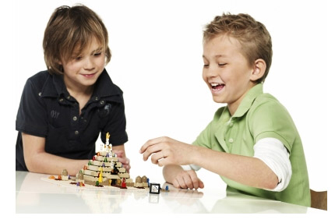

What characteristics will this help students overcome?
- poor ability to be empathetic to others perspectives
- poor impulse control
- inability to generate multiple and effective solutions to problems faced in the classroom
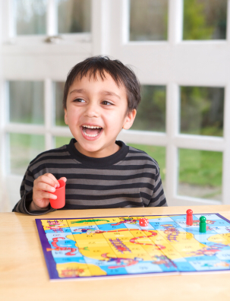

How do I use this as a teacher who has never heard of it?
- Discuss expectations with the students peers before game play and encourage interaction
- Assign peer advocates, a peer mentor, or a buddy
- Assign a teacher advocate to the student, with whom the student can consult for guidance, general support, or crisis assistance
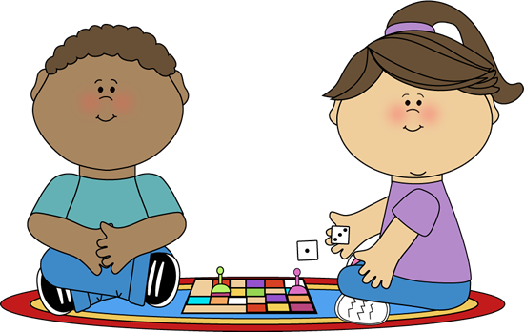
Woks cited
Cruz, R. E., Cage, C. E., & Lian, M. J. (2000). Lets Play Mancala and Sungka! TEACHING Exceptional Children, 32(3), 38-42.
Promoting Positive Social Interactions in an Inclusion Setting for Students with Learning Disabilities. (n.d.). National Association of Special Education Teachers, 1-11.
Sartini, E. C., Knight, V. F., & Collins, B. C. (2013). Ten Guidelines to Facilitate Social Groups for Students with Complex Special Needs. TEACHING Exceptional Children, 45(3), 54-62.

