Who is Holly?
Holly huffs and hustles,
to get to the bus,
determined to be the first to class.
How is Holly?
She tries to sit and catch her breath.
What will Holly do?
She recalls her breathing tips to help with her breathing.
Suddenly Holly’s friend Betty rushes onto the bus.
Holly goes to comfort the crying Betty.
Holly then asks, “Why don’t we try a breathing tip?”
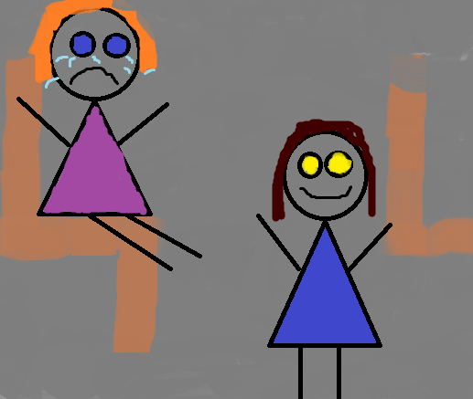
Slowly, the bus comes to a stop.
Both Holly and Betty run off the bus,
just as they encounter Gus.
Gus then says, “You ready to take our test!”
Holly replies, “Today?” as her and Betty went to class.
Holly walks to her desk,
as she worries about the test.
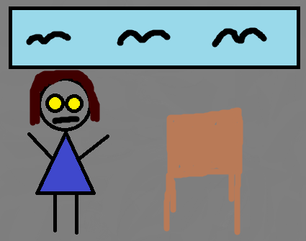
Betty then says, “Why don’t you study your notes?”
Holly looks to see that she forgot her notes.

How is Holly?
She needs to calm down to not stress her breathing.
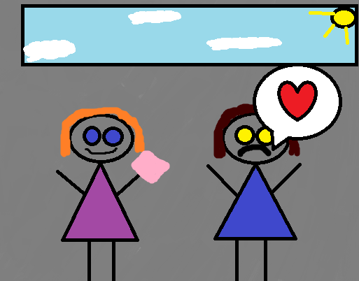
What will Holly do?
She might try using Betty’s sticky note tips.

Holly recalls that Betty likes to study the notes with stickies.
Holly asks Betty, “Can I borrow some of your sticky notes?”
Betty replies, “Sure you can!” as she hands some to Holly.
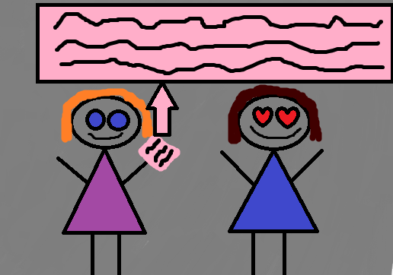
What more could happen with gym around the corner?

Gus then runs to ask, “Why are you in gym Holly?”
Holly replies, “Why shouldn’t I be in gym?”
Gus replies, “Because wouldn’t it be hard on your asthma?”
Patiently Holly smiles and says, “Why don’t we race to find out?”
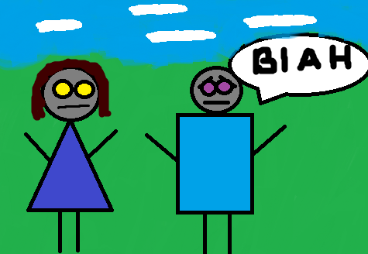
So the great race begins……

How is Holly?
She feels mad because of Gus’ question.
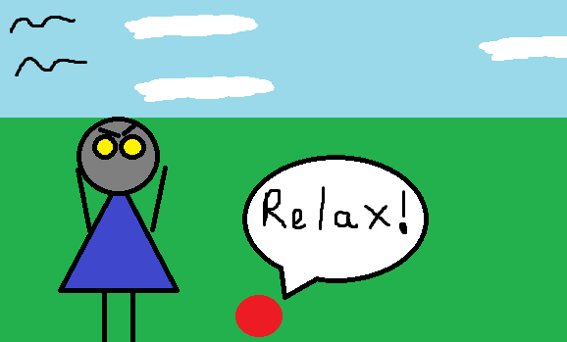
What will Holly do?
She might try a stress ball to relieve some of her anger.

As the race comes to a close,
both runners are neck and neck,
both leap and stretch out their hands,
but only one hand passes the dirt line.
Holly’s classmates cheer as Holly stands up brushing the dirt off smiling.
Holly walks over to help Gus up.
Gus now realizes that Holly can run too.
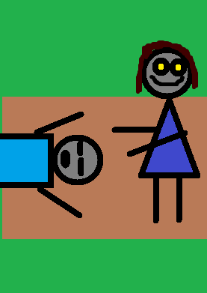
But the day isn’t over yet just as Holly begins to feel drowsy.
How is Holly?
She feels tired from today’s activities and sometimes coughing at night.
What will Holly do?
She can rest her eyes a bit to help herself recover some rest.
As the day comes to a close her teacher comes over with her test.
Mr. K says, “Holly you did a great job on your test!”
As Mr. K turned to walk away he thought to himself that Holly was one bright kid.
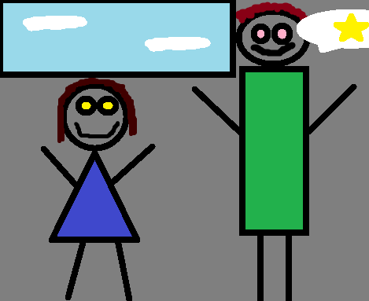
The bell rang so Holly and the other students went to the bus....

What does this all mean?
We now know,
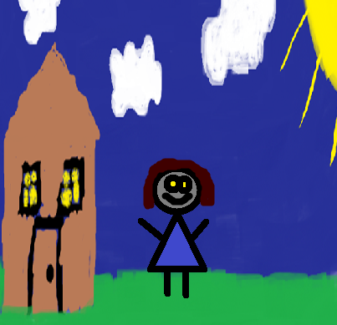
who is Holly.
Who is Holly?
Illustrated By: Ava Olivarez

Who
is
Holly?

Illustrated By: Ava Olivarez

I would like to thank my little cousin Ava for creating the images throughout the book. The book was mainly about a student with Asthma that ends up showing the reader more about herself and see the other side. All in all it was a great opportunity to create this book.
Problems: Breathing, Worried, Anger, Sleepy
Solutions: Breathing Tips, Sticky Notes, Stress Ball, Resting Breaks

